UNITED STATES
SECURITIES AND EXCHANGE COMMISSION
Washington, D.C. 20549
FORM 8-K
CURRENT REPORT
PURSUANT TO SECTION 13 OR 15(d) OF THE SECURITIES EXCHANGE ACT OF 1934
Date of Report (Date of Earliest Event Reported): August 11, 2026
BEYOND MEAT, INC.
(Exact name of registrant as specified in its charter)
Delaware |  |  |  |  |  | 001-38879 |  |  |  |  |  | 26-4087597
(State or other jurisdiction  of incorporation) |  |  |  |  |  | (Commission File Number) |  |  |  |  |  | (I.R.S. Employer  Identification Number)
888 N. Douglas Street, Suite 100
El Segundo, California 90245
(Address of principal executive offices, including zip code)
(866) 756-4112
(Registrant’s telephone number, including area code)
Not Applicable
(Former Name or Former Address, if Changed Since Last Report)
Check the appropriate box below if the Form 8-K filing is intended to simultaneously satisfy the filing obligation of the registrant under any of the following provisions:
☐ |  |  | Written communications pursuant to Rule 425 under the Securities Act (17 CFR 230.425)
☐ |  |  |  |  |  | Soliciting material pursuant to Rule 14a-12 under the Exchange Act (17 CFR 240.14a-12)
☐ |  |  | Pre-commencement communications pursuant to Rule 14d-2(b) under the Exchange Act (17 CFR 240.14d-2(b))
☐ |  |  | Pre-commencement communications pursuant to Rule 13e-4(c) under the Exchange Act (17 CFR 240.13e-4(c))
Securities registered pursuant to Section 12(b) of the Act:
Title of each class |  |  |  |  |  | Trading Symbol(s) |  |  |  |  |  | Name of each exchange on which registered
Common Stock, $0.0001 par value |  |  |  |  |  | BYND |  |  |  |  |  | The Nasdaq Stock Market LLC
Indicate by check mark whether the registrant is an emerging growth company as defined in Rule 405 of the Securities Act of 1933 (§230.405 of this chapter) or Rule 12b-2 of the Securities Exchange Act of 1934 (§240.12b-2 of this chapter). Emerging growth company ☐
If an emerging growth company, indicate by check mark if the registrant has elected not to use the extended transition period for complying with any new or revised financial accounting standards provided pursuant to Section 13(a) of the Exchange Act. ☐

Item 8.01 |  |  | Other Events.
As previously disclosed, on November 19, 2025, the stockholders of Beyond Meat, Inc. (the “Company”) approved thirty alternate amendments to the Company’s Restated Certificate of Incorporation to effect a reverse stock split (the “Reverse Stock Split”) of the Company’s common stock, par value $0.0001 per share (the “Common Stock”), at one of thirty reverse stock split ratios, with the exact ratio to be determined by the board of directors of the Company (the “Board”), and a proportionate reduction in the number of authorized shares of Common Stock (and a corresponding decrease in the total number of authorized shares of capital stock) (the “Authorized Share Reduction”). On August 11, 2026, the Company announced that the Board has selected a 1-for-30 reverse stock split ratio. The Reverse Stock Split and Authorized Share Reduction are expected to become effective on August 13, 2026, at 11:59 p.m. Eastern Time (the “Effective Time”). Shares of Common Stock are expected to begin trading on a split-adjusted basis on the Nasdaq Global Select Market at market open on August 14, 2026 under the existing trading symbol “BYND” and a new CUSIP number of 08862E307. The Reverse Stock Split is intended to help the Company regain compliance with the minimum bid price requirement for continued listing on the Nasdaq Global Select Market.
In connection with the Reverse Stock Split, every 30 shares of Common Stock issued and outstanding immediately prior to the Effective Time will be automatically reclassified and combined into 1 share of Common Stock. No fractional shares of Common Stock will be issued as a result of the Reverse Stock Split. Instead, the Company will issue to holders of record who are entitled to a fraction of a share as a result of the Reverse Stock Split, a fraction of a share of Common Stock as is necessary to round up to the nearest whole share. For shares held through The Depository Trust Company ("DTC"), fractions of shares will be issued as is necessary to round up to the nearest whole share at the DTC participant level. Brokers, banks or other nominees holding shares in "street name" will be instructed to effect the Reverse Stock Split for their beneficial holders; however, such brokers, banks or other nominees may apply their own specific procedures for processing the Reverse Stock Split.
Upon the effectiveness of the Reverse Stock Split, the conversion rates of the Company’s outstanding convertible notes (including the 7.00% Convertible Senior Secured Second Lien PIK Toggle Notes due 2030 and the 0% Convertible Senior Notes due 2027), the number of shares of Common Stock issuable upon exercise of outstanding warrants and the exercise prices thereof, and the number of shares subject to outstanding equity awards under the Company’s equity incentive plans (and the applicable exercise prices thereof), will each be proportionately adjusted pursuant to their respective terms and as determined by the Board to reflect the 1-for-30 reverse stock split ratio. In addition, the number of shares reserved for future issuance under the Company's equity incentive plans will be proportionately reduced.
In connection with the Authorized Share Reduction, the number of authorized shares of Common Stock will be reduced from 3,000,000,000 to 100,000,000, and the total number of authorized shares of capital stock will be correspondingly reduced from 3,000,500,000 to 100,500,000.
A copy of the press release announcing the Reverse Stock Split and Authorized Share Reduction is attached hereto as Exhibit 99.1 and is incorporated herein by reference.

Note Regarding Forward-Looking Statements.
Certain statements in this Current Report on Form 8-K constitute “forward-looking statements” within the meaning of the federal securities laws. These statements are based on management’s current opinions, expectations, beliefs, plans, objectives, assumptions or projections regarding future events or future results. Forward-looking statements include statements regarding the expected timing and effectiveness of the Reverse Stock Split and Authorized Share Reduction, the anticipated adjustments to the Company’s outstanding convertible notes, warrants and equity awards, and the anticipated impact of the Reverse Stock Split on the Company’s ability to regain compliance with the Nasdaq minimum bid price requirement. These forward-looking statements are only predictions, not historical fact, and involve certain risks and uncertainties, as well as assumptions. Actual results, levels of activity, performance, achievements and events could differ materially from those stated, anticipated or implied by such forward-looking statements. While the Company believes that its assumptions are reasonable, it is very difficult to predict the impact of known factors, and, of course, it is impossible to anticipate all factors that could affect actual results. There are many risks and uncertainties that could cause actual results to differ materially from forward-looking statements made or implied herein including the risks discussed under the heading “Risk Factors” in the Company’s Annual Report on Form 10-K for the fiscal year ended December 31, 2025 filed with the Securities and Exchange Commission (“SEC”) on April 9, 2026, the Company’s Quarterly Report on Form 10-Q for the fiscal quarter ended March 28, 2026 filed with the SEC on May 7, 2026, and the Company’s Quarterly Report on Form 10-Q for the fiscal quarter ended June 27, 2026 filed with the SEC on August 6, 2026, as well as other factors described from time to time in the Company’s filings with the SEC. Such forward-looking statements are made only as of the date of this Current Report on Form 8-K. The Company undertakes no obligation to publicly update or revise any forward-looking statement because of new information, future events or otherwise, except as otherwise required by law. If it does update one or more forward-looking statements, no inference should be made that the Company will make additional updates with respect to those or other forward-looking statements.

Item 9.01 Financial Statements and Exhibits.
(d) Exhibits
Exhibit  Number |  |  |  |  |  | Description
99.1 |  |  |  |  |  | Press release issued by Beyond Meat, Inc. dated August 11, 2026
104 |  |  |  |  |  | Cover page interactive data file (embedded with the inline XBRL document)

SIGNATURES
Pursuant to the requirements of the Securities Exchange Act of 1934, the registrant has duly caused this report to be signed on its behalf by the undersigned hereunto duly authorized.

BEYOND MEAT, INC.
By: |  |  | /s/ Lubi Kutua
 |  |  | Lubi Kutua
 |  |  | Chief Financial Officer and Treasurer
Date: August 11, 2026

Exhibit 99.1
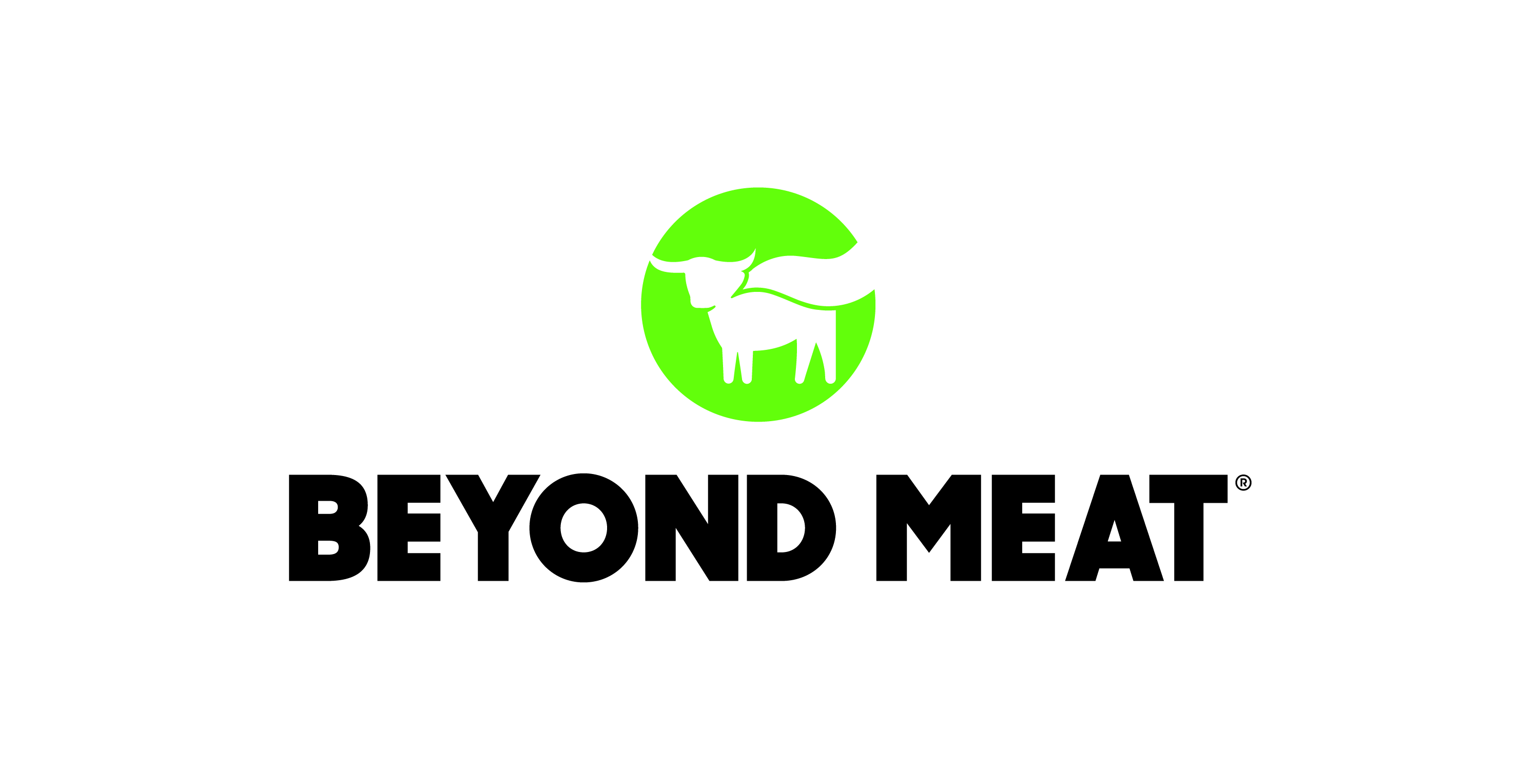
Beyond Meat Announces 1-for-30 Reverse Stock Split

EL SEGUNDO, Calif., August 11, 2026 (GLOBE NEWSWIRE) — Beyond Meat, Inc. (NASDAQ: BYND) (the “Company”) today announced that its board of directors (the “Board”) has selected a 1-for-30 reverse stock split of the Company’s common stock and a proportionate reduction in the number of authorized shares of common stock (and a corresponding decrease in the total number of authorized shares of capital stock). At a special meeting held on November 19, 2025, the Company’s stockholders approved thirty alternate amendments to the Company’s restated certificate of incorporation to effect a reverse stock split at one of thirty reverse stock split ratios, with the exact ratio to be determined by the Board.

The reverse stock split is intended to help the Company regain compliance with the minimum bid price requirement for continued listing on the Nasdaq Global Select Market.

“We believe the reverse stock split is an important step toward maintaining our Nasdaq listing and better positioning our stock for long-term investor participation,” said Ethan Brown, President and Chief Executive Officer of Beyond Meat.

The reverse stock split is expected to become effective at 11:59 p.m. Eastern Time on August 13, 2026. Shares of the Company’s common stock are expected to begin trading on a split-adjusted basis on the Nasdaq Global Select Market at market open on August 14, 2026 under the existing trading symbol “BYND” and a new CUSIP number of 08862E307.

In connection with the reverse stock split, every 30 shares of the Company’s common stock issued and outstanding immediately prior to the effective time will be automatically reclassified and combined into 1 share of common stock.

No fractional shares of common stock will be issued as a result of the reverse stock split. Instead, the Company will issue to holders of record who are entitled to a fraction of a share as a result of the Reverse Stock Split, a fraction of a share of common stock as is necessary to round up to the nearest whole share. For shares held through The Depository Trust Company ("DTC"), fractions of shares will be issued as is necessary to round up to the nearest whole share at the DTC participant level. Brokers, banks or other nominees holding shares in "street name" will be instructed to effect the reverse stock split for their beneficial holders; however, such brokers, banks or other nominees may apply their own specific procedures for processing the reverse stock split.

In connection with the authorized share reduction, the number of authorized shares of common stock will be reduced from 3,000,000,000 to 100,000,000, and the total number of authorized shares of capital stock will be correspondingly reduced from 3,000,500,000 to 100,500,000.

Upon the effectiveness of the reverse stock split, the conversion rates of the Company’s outstanding convertible notes, the number of shares of common stock issuable upon exercise of outstanding warrants and the exercise prices thereof, and the number of shares subject to outstanding equity awards under the Company’s equity incentive plans (and the applicable exercise prices thereof), will each be proportionately adjusted pursuant to their respective terms and as determined by the Board to reflect the 1-for-30 reverse stock split ratio. In addition, the number of shares reserved for future issuance under the Company’s equity incentive plans will be proportionately reduced.

The reverse stock split has no effect on the par value of the Company’s common stock. Immediately after the reverse stock split, each stockholder’s percentage ownership interest in the Company and proportional voting power will remain unchanged, except for minor changes that will result from the treatment of fractional shares.

Equiniti Trust Company, LLC is acting as the transfer and exchange agent for the reverse stock split. Stockholders who hold registered shares in book-entry form at Equiniti Trust Company, LLC are not required to take any action to receive split-adjusted shares. Stockholders who hold shares through a broker, bank or other nominee will have their positions automatically adjusted and are not required to take any action.

About Beyond Meat

Beyond Meat, Inc. (NASDAQ: BYND), otherwise known as Beyond The Plant Protein Company™, is a plant protein company offering a portfolio of plant-based products made with non-GMO ingredients, no added hormones or antibiotics, and 0mg of cholesterol per serving. Founded in 2009, Beyond Meat’s core products are designed to have the same taste and texture as animal-based meat while being better for people and the planet. The company’s brand promise, Eat What You Love®, represents a strong belief that there is a better way to feed our future and that the positive choices we all make, no matter how small, can have a great impact on our personal health and the health of our planet. By shifting from animal-based protein to plant-based protein, we can positively impact four growing global issues: human health, climate change, constraints on natural resources and animal welfare. Visit www.BeyondMeat.com and follow @BeyondMeat on Facebook, Instagram, Threads and LinkedIn.

Beyond Meat Forward Looking Statements

Certain statements in this release constitute “forward-looking statements” within the meaning of the federal securities laws. These statements are based on management’s current opinions, expectations, beliefs, plans, objectives, assumptions or projections regarding future events or future results. Forward-looking statements include statements regarding the expected timing and effectiveness of the reverse stock split and authorized share reduction, the anticipated adjustments to the Company’s outstanding

convertible notes, warrants and equity awards, and the anticipated impact of the reverse stock split on the Company’s ability to regain compliance with the Nasdaq minimum bid price requirement. These forward-looking statements are only predictions, not historical fact, and involve certain risks and uncertainties, as well as assumptions. Actual results, levels of activity, performance, achievements and events could differ materially from those stated, anticipated or implied by such forward-looking statements. While the Company believes that its assumptions are reasonable, it is very difficult to predict the impact of known factors, and, of course, it is impossible to anticipate all factors that could affect actual results. There are many risks and uncertainties that could cause actual results to differ materially from forward-looking statements made or implied herein including the risks discussed under the heading “Risk Factors” in the Company’s Annual Report on Form 10-K for the fiscal year ended December 31, 2025 filed with the Securities and Exchange Commission (“SEC”) on April 9, 2026, the Company’s Quarterly Report on Form 10-Q for the fiscal quarter ended March 28, 2026 filed with the SEC on May 7, 2026, and the Company’s Quarterly Report on Form 10-Q for the fiscal quarter ended June 27, 2026 filed with the SEC on August 6, 2026, as well as other factors described from time to time in the Company’s filings with the SEC. Such forward-looking statements are made only as of the date of this release. The Company undertakes no obligation to publicly update or revise any forward-looking statement because of new information, future events or otherwise, except as otherwise required by law. If it does update one or more forward-looking statements, no inference should be made that the Company will make additional updates with respect to those or other forward-looking statements.

Media:
Shira Zackai
shira.zackai@beyondmeat.com

Investors:
Raphael Gross
beyondmeat@icrinc.com

